Story board
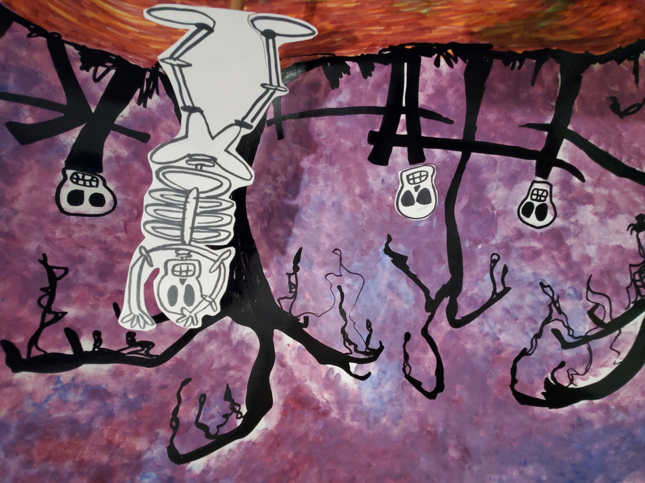  first scene entrance | 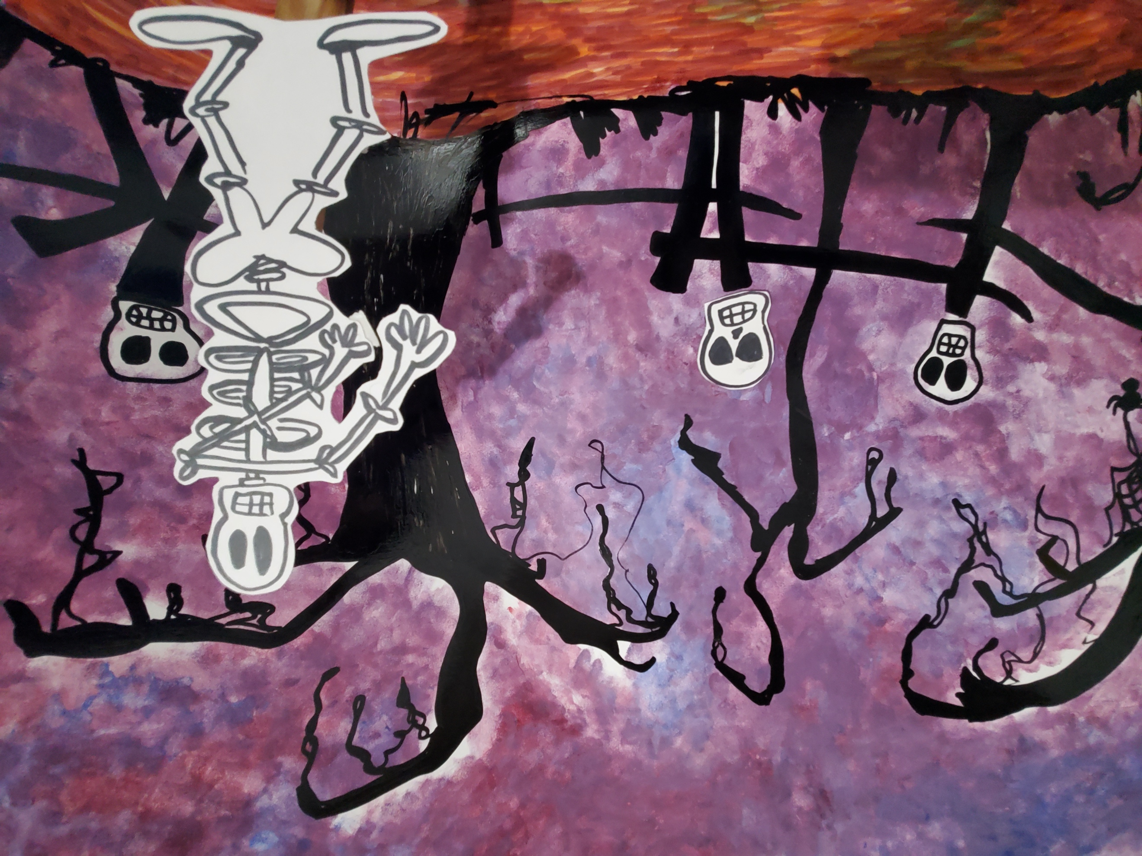  entrance of dancing skeleton

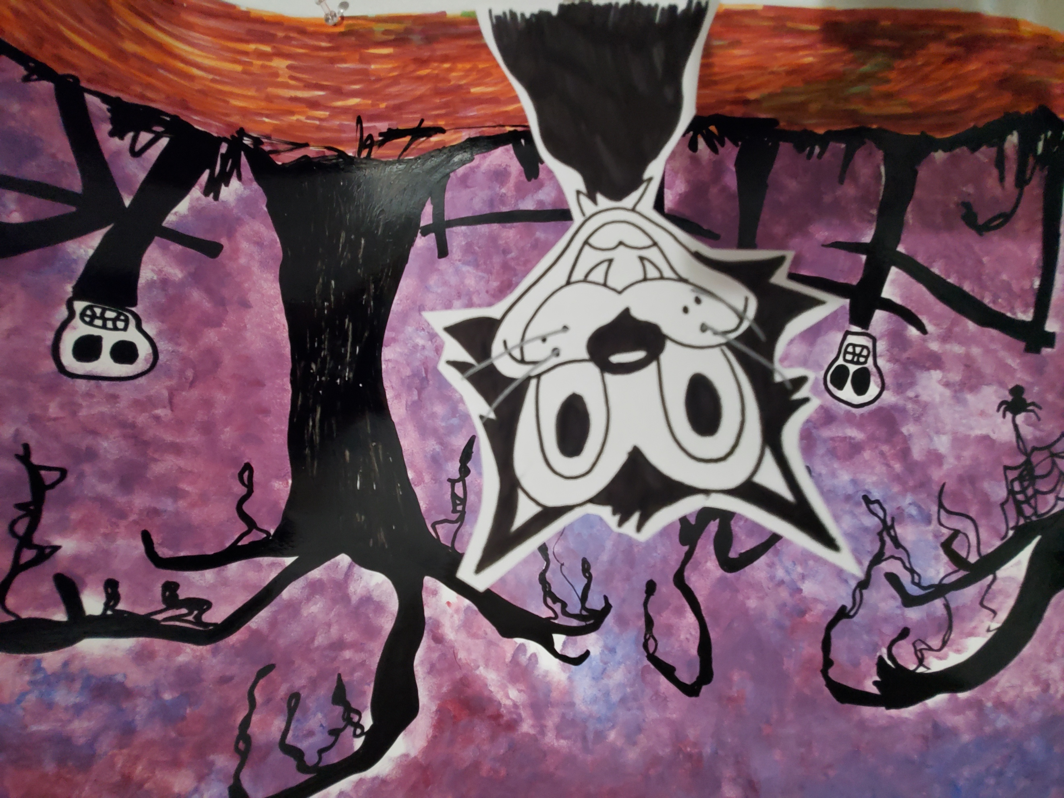  front view scene of moving eyes | 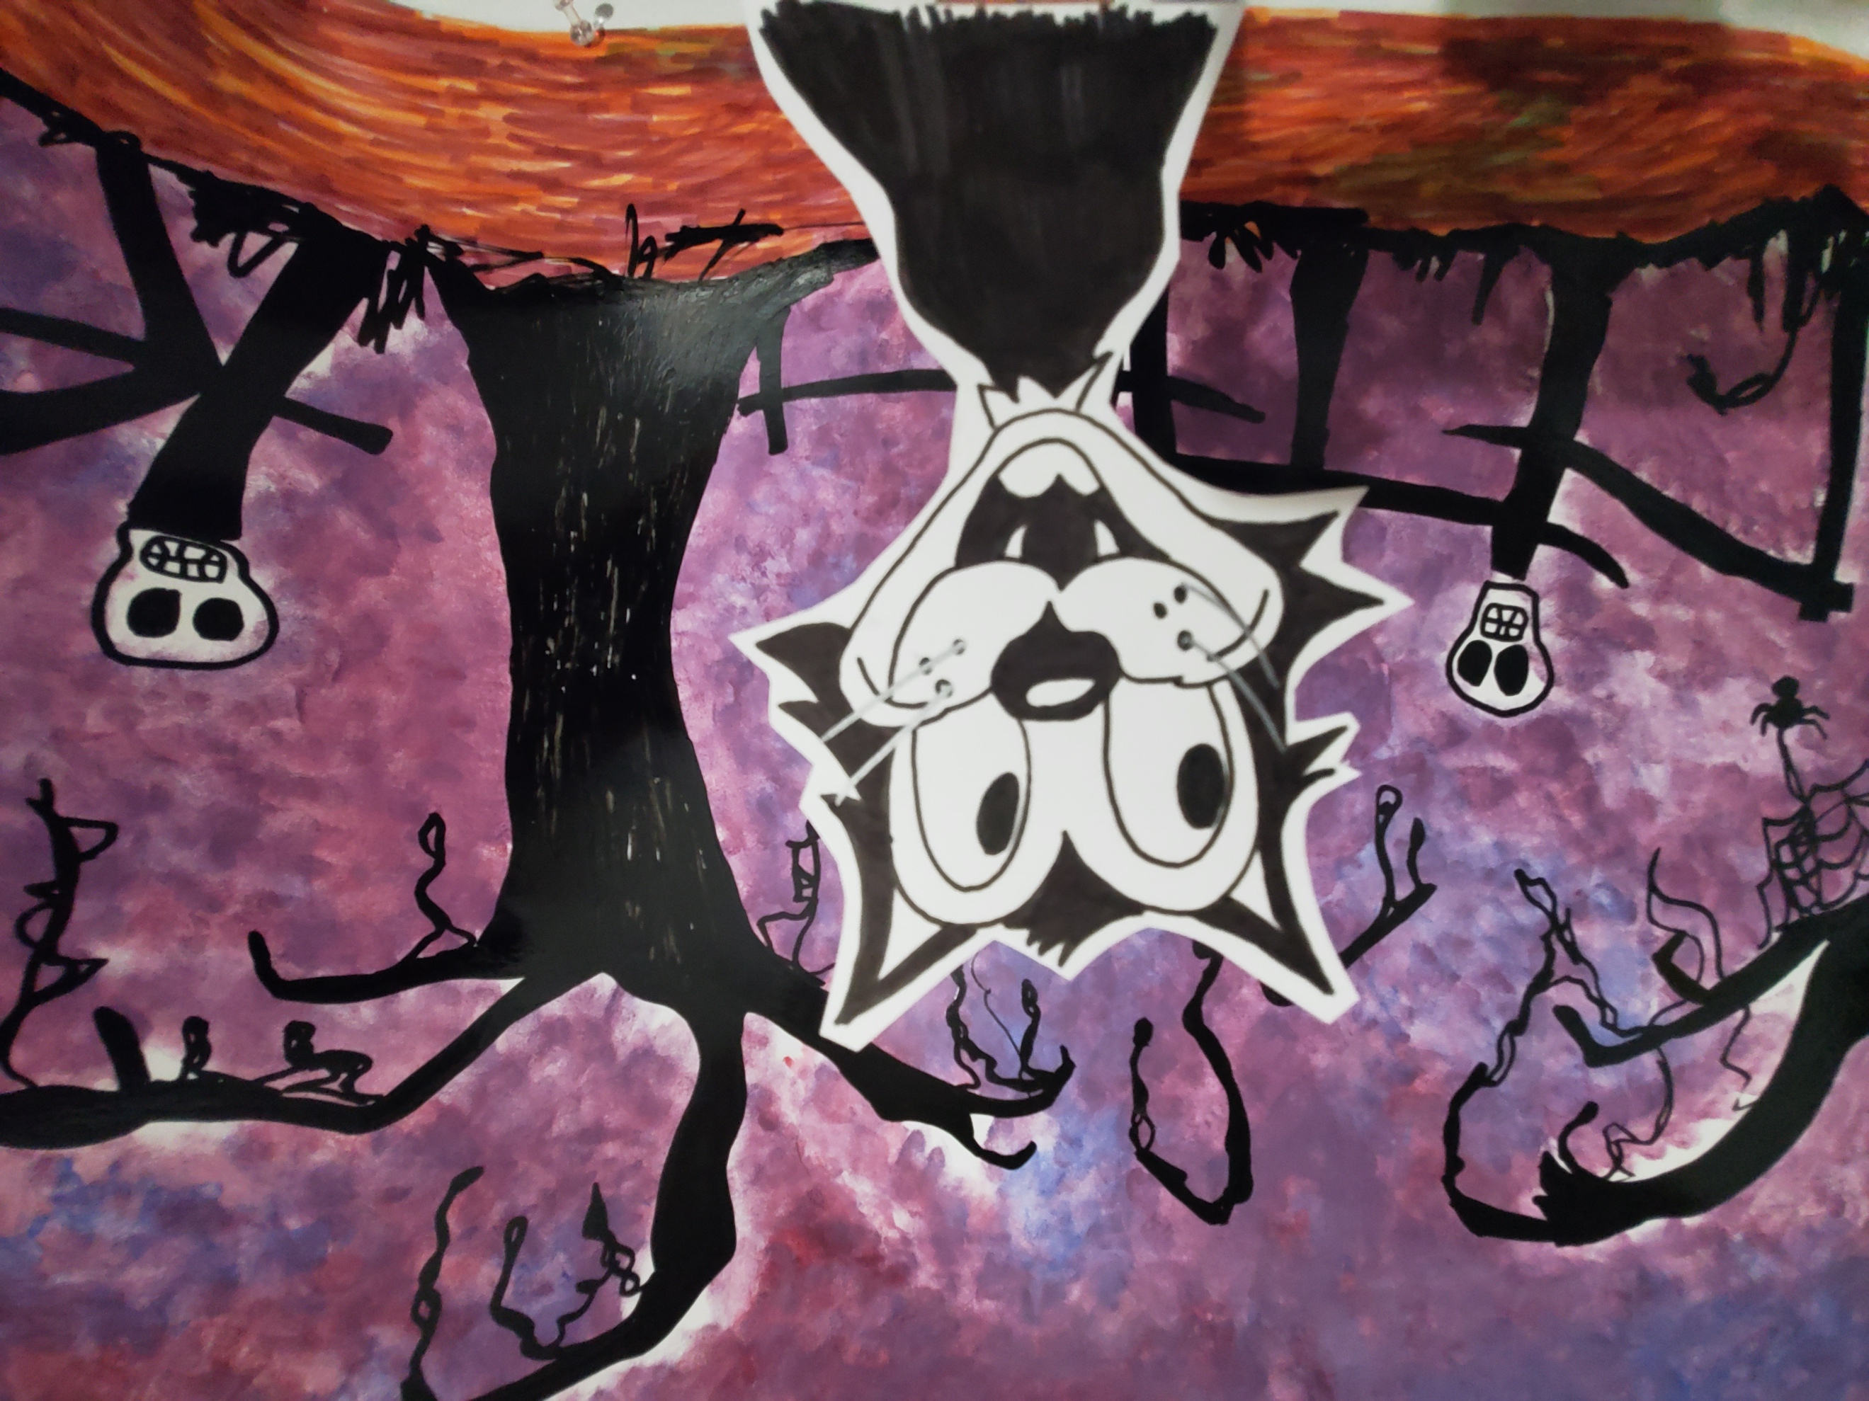  side scene of moving eyes
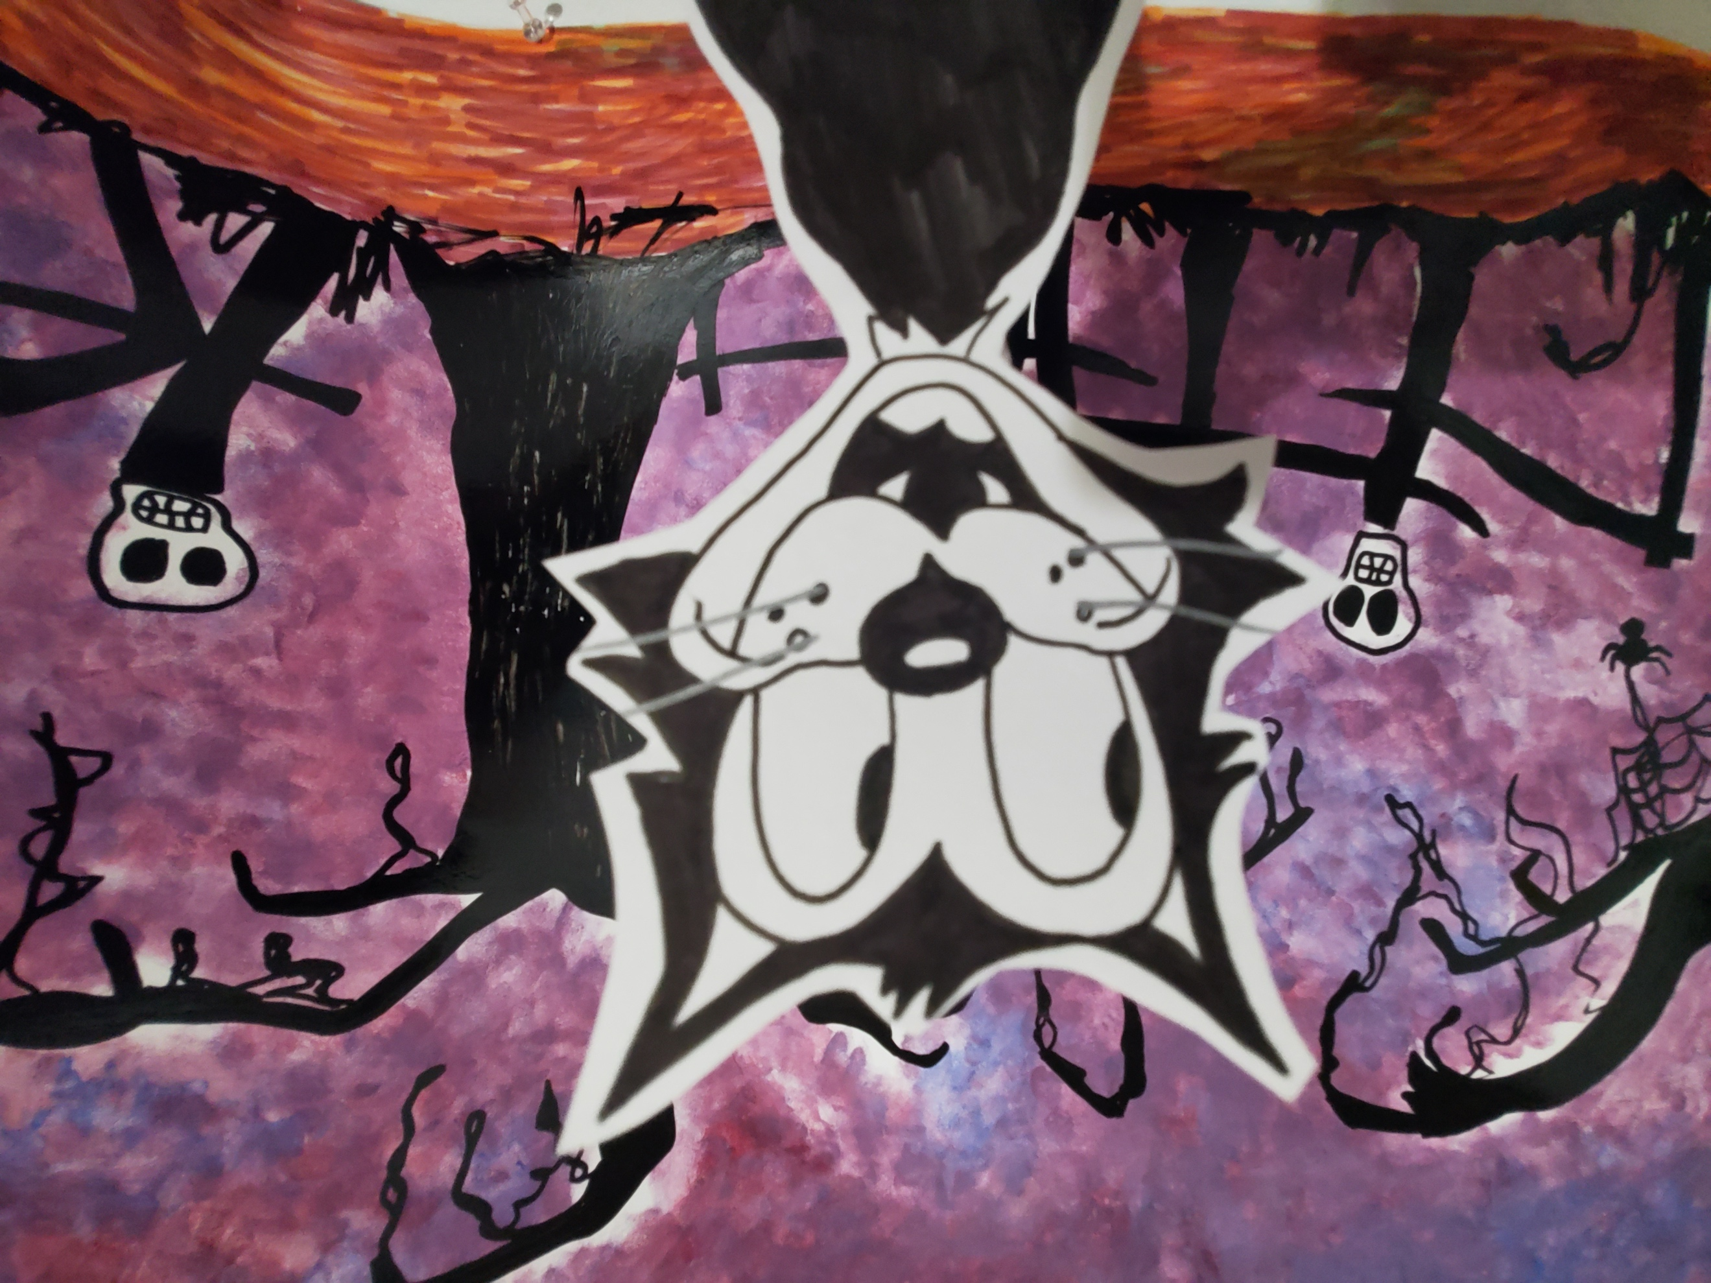  third and | 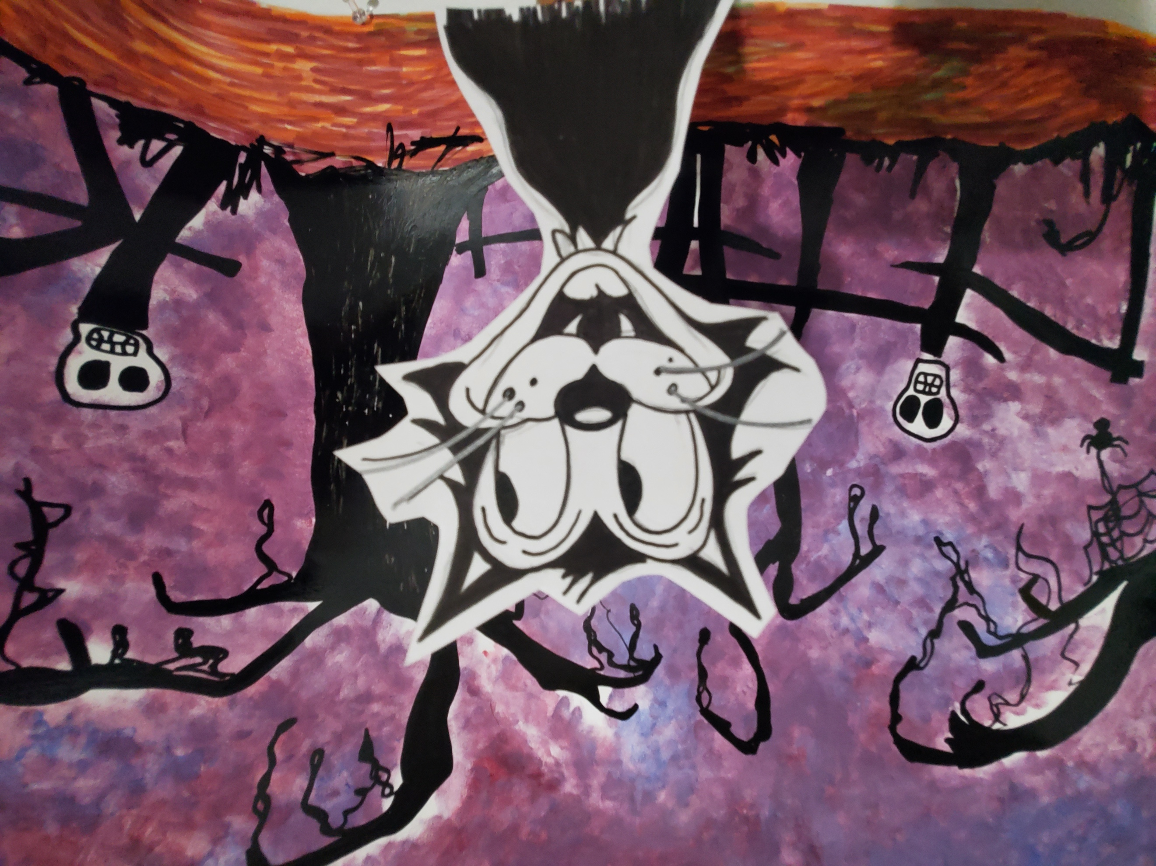  last scene of cat moving eyes

The rest of the scenes is the same skeleton moving his body and the photos are repeating during the dance of the spooky song.

